June 2021 Live Partner Collaboration Session Summary

Date of session: 9.6.21

Attendees: NHS login team & Live Partners

Scaling Overview
- Updated partners on the scaling work being undertaken by NHS login to ensure the service stays safe and robust as users increase due to NHS login being used for COVID services
- Principles of the work are;
  - Protect the manual ID checker process
  - Keep people in PYI automation (where eligible for IDVM) or re-direct them to the POL route
  - Manage volumes throughout the service to ensure continuous throughput
  - Inform users what is required/happening at each step
- For high level of verification P9, the numbers of users are;
  - 36% of users from IDVM
  - 36% of users from PYI automation
  - 27% users from PYI manual (ID checking)
  - -1% via GP online credentials
- Queue size and queue time reduced…

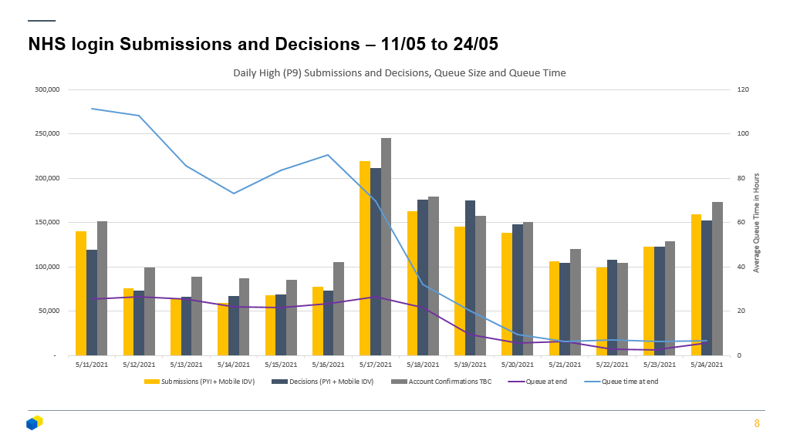

- Benefit to Partner: Protecting partner services from any surges in user numbers due to COVID initiatives using NHS login

Scaling Prove Your Identity (PYI)

- Aims:​
  - Don't overwhelm the ID checker queue​
  - Protect parts of the PYI journey from surges in traffic​
  - Keep more people on automation​

- Approach:​
  - Boost transaction limits across 3rd party services​
  - Limit traffic at various points in the PYI journey​
  - Increase the % of users kept on automation
​
- Increased transactions per minute for 3rd parties;
  - iProov increased to 32 tps
  - Paycasso doc check – 16tps (currently testing)
  - Paycasso preflights – 16tps (tested)
  - PDS – 350tps (across the entire service)

- Rate limiting within PYI;
  - Throttling capability for automation / manual / POL
  - Rate limiting pre-flight checks
  - Waiting page for users when limits are reached
- Keeping people on automation;
  - Changes to face scan initiation page
  - Introduction of retry attempts for ID document submission & retrieval
  - Improved name matching
- ID Checker App improvements;
  - Load testing
  - Performance evaluation following initial traffic spike
  - Improved monitoring & alerting
  - Extension of ID checker pool to support new starters

- Partner Benefit of scaling work; ensuring users still successfully register without any negative impact from the increased volumes of traffic for the service
General Functional Updates
IDVM number updates
- 2 weeks ago – 791,962
- Today – 1,138,751
- Successfully numbers of users being verified to P9 level via IDVM
- Partner Benefit: Easier user journey being provided by IDVM so more users get through successfully
P0 Email verification process
- We know the P0 conversion rate is approx. 88%. We know users get confused / lost in the current email verification process and finding their way back to NHS login to continue the mobile registration.
- ​During the surge (on NHS App) the P0 conversion rate increased to 94%. This validates the rationale that if users can easily find their way back to NHS login (i.e. an app-based service) this will increase the conversion.
- Solution;
  - Development to generate new security code within the journey
  - New Cognito email template to include the security code
  - P0 email confirmation averaging 93-95% following the change

- Partner Benefit: Improved journey through email verification to ensure more users get through and back to the partner service
New rate limiting screen (PDS)
- New screen to show when the service is busy (checking PDS) and to try later or carry on with NHS number
- Partner Benefit: Keeping users informed so they will retry or use another method and go on to finish the journey
Updating where to find your NHS number – Vaccination Letter
- New screen providing users with suggestions of where they will find their NHS number
- Partner Benefit: Educating users on finding NHS number which may also benefit some partner services

