May 2021 Live Partner Collaboration Session Summary

Date of session: 5.5.21

Attendees: NHS login team & Live Partners

IProov Android SDK

- Aim:​To provide the automation journey to users that would normally be forced onto the manual route.​
- Being released this week by NHS App​
- Expecting:​
- Improved pass rates​
- Better failure feedback​
- Improved user experience​

Partner Benefit: Improved numbers of user going through the automation route rather than the manual route – with greater potential for successful journey
Multiple Faces Update – Two face detection on ID documents
- Aim: Ensure users with ID docs with multiple images stay on the automation journey​
- Prior to switch on 20.49% of traffic was directed down the manual journey. This has dropped to 3.83%​
- Partner Benefit: More users going down automation route with a higher level of success rate

Transcoding
- Aim: Ensure all videos captured by users can be used during registration regardless of file type​
- Current progress;
  - First phase of Video Transcoding is dev complete​
  - Successful testing conducted in production​
  - Release pending​
​
- Next steps: Extend transcoding to other file types & change validation rules​
- Partner benefit: Greater numbers of users getting through the journey using more types of devices

Device Transition (Deprioritised)
- Aim: Allow users to follow the most suitable registration journey given their device, OS & browser​
- Progress:​
  - User research complete​
  - Back-end development complete​
  - Re-design of front end pending, following UR outcomes​
​
- Next steps:​ Work deprioritised (but ongoing) due to scaling priorities​

Document Capture Paycasso SDK

- Work involves ensuring better capturing of photo ID documentation
- Work de-prioritised due to scaling for COVID-19

IDVM Update

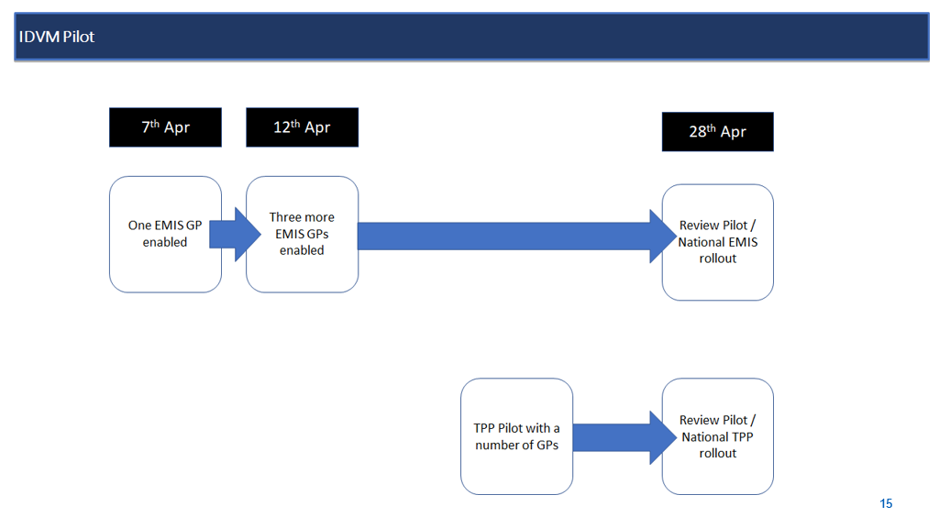

What is IDVM?

- User is at P0 low level of verification and is asked for email address
- Then asked if they know their NHS number (giving them P5 level of verification)
- IDVM checks PDS based on the NHS number provided and if correct presents details to user to confirm which then uplifts them to P9 level
- Demo was shown
- Partner Benefit: Will provide users with a quicker and easier route to uplift to P9 without having to go through the Prove Your Identity route

COVID Services
- Supporting Covid services with NHS login – at P0 level
  - Register a result of a lateral flow test​
  - Isolation payment due to COVID Tracing App notification​
  - Provide details of potential contacts if you've tested positive​
- 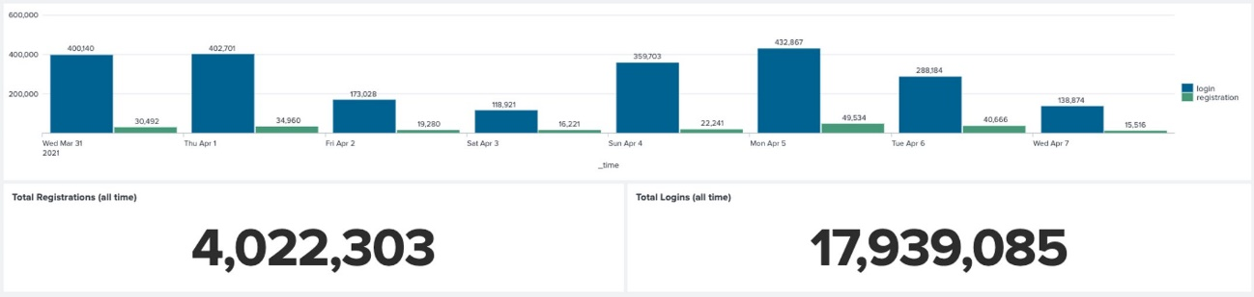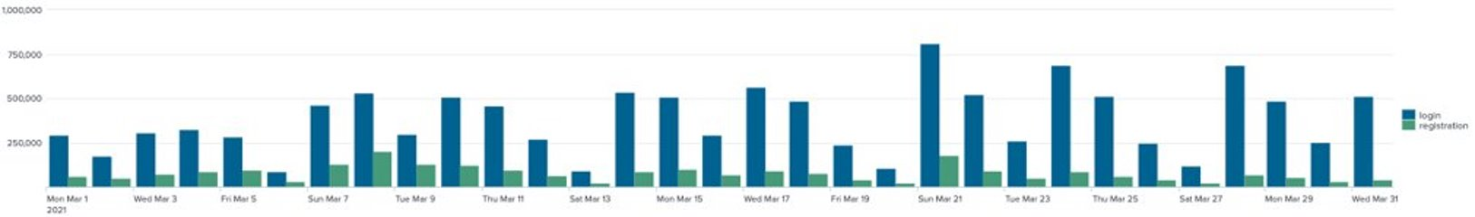
- Partner Benefit: Increase awareness, understanding and numbers of user with NHS login thereby helping users to a partner service to use NHS login as a quicker, secure and convenient login option

