February 2021 Live Partner Collaboration Session Summary

Date of session: 3.2.21

Attendees: NHS login team & Live Partners

Iproov IOS SDK
- Presented the benefits of Iproov IOS vs a web based IOS app, see below;
Partner Benefit: Improved user journey for users and higher overall success rates

Two Face Detection Update
- Development work to look at two face photo ID detection and acceptance - complete
- Multiple rounds of testing at different similarity values.​
- AWS Recognition similarity threshold set (80%).​
- Release to live (switched off).​
- Reporting and auditing dashboard being set up to monitor performance.​

Partner Benefit: Improved acceptance rates of ID with 2 faces on

Device Transition
- NHS login should be able to support all users and guide them to the most appropriate login journey regardless of the device or platform they are using.​
- Record and Report on known issues – Enhanced reporting and better evidence will assist us to see what other device/browser issues exist that we are not aware of – Final two tickets are in development.​
- Enhance the Browser Error Page – Better on-screen instructions for users who get this error – DONE ​
- Resolving browser/device specific issues – Extend the number of browsers and devices that can be pushed to video successfully - In progress, testing to start on problematic devices.​
- Audio and Camera permissions - Ensure users grant access to audio and camera – Design work done, looking to do a small round of UR on this before it goes to Dev.​

Partner Benefit: Improved support for more devices enabling more users to get through the journey successfully

Video Management and Transcoding Update
- The long-term goal for this work is to allow our users to upload different video files types whilst recording a video selfie so they can successfully verify their identity. We currently only accept MP4, MOV and WebM. ​
- Enable transcoding for MOV and Web4 videos in to MP4 videos – MVP done​
- Transcoding in ID Checker App and QA changes – In progress​
- Reporting on transcoding – In progress​
- Open transcoding to all other video file types – Coming next​
- Video regression phase - Work through known bugs at the record and review video stage.​

Partner Benefit: Broadening acceptance of video file types to enable more users to complete journey successfully

Paycasso SDK

- Conducted usability testing
- Participants​;
  - 12 Users​
  - Ages 28 – 70; Varying technical ability; one with visual impairment​
  - Mix of mobile devices​
- Key findings​;
  - Majority of users managed to capture an image (11/12)​
  - Simplified instructions and review page meant users were unsure when an image was captured or was going to be captured.​
  - ​Some users were familiar with the technology (from online banking) and liked it, some not.​
  - ​Visually impaired user unable to complete capture (1/12)​

- ​Next Steps;
  - Content considerations​
    - Introduction of screen-reader content for users to ensure users are informed​
    - Introduction of back functionality so users can change to alternative route​
    - Re-working of content before and after capture​
  - Other considerations​
    - Users unfamiliar with the technology felt they needed support, but were able to capture images.​
    - Additional testing and further review of image capture quality needed to solidify findings.​

Partner Benefit: improving the use of image capturing for all users to ensure a better user experience

PDS Rollout
- Looking at national rollout of users being able to update their contact details…
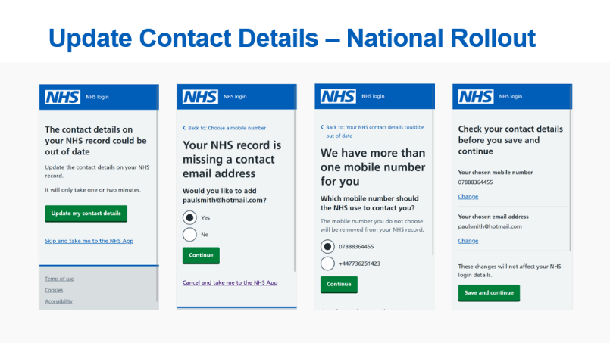
NHS Account
- Exploring the concept of an NHS account. The user benefits would be;
  - Personalisation
  - Simpler interactions
  - Starting place
  - Commonality
  - Familiarity
  - An anchor
  - Stepping stone

Mobile IDV
- Will launch early March 2021, P5 is a pre-requisite
- Development work 30% complete
- Initially for EMIS only patient online users
- Initially for users where their mobile number matches PDS

