NDRS-NICE partnership report

Background
This report was produced in partnership by the National Disease and Registration Service (NDRS) and National Institute for Health and Care Excellence (NICE). NDRS and NICE have established a partnership focused on routinely collected data to support NICE decision making on the appraisals of cancer treatments. The partnership uses NDRS datasets, including the information submitted by trusts to the Systemic Anti-Cancer Therapy (SACT) dataset, to provide an understanding of current practice.
To determine a severity modifier, NICE considers factors such as the age, gender, and overall survival of the patient cohort affected by the disease. Additionally, knowing the time-on-treatment for each therapy is useful, as it validates assumptions made in technology appraisal evaluations about the duration of treatment use.
This partnership is focused on producing demographic and survival information using NDRS data, alongside supplementary information tailored to each technology appraisal. These may include, for example, the time patients spend on particular treatments, genetic data where this is available, or other information on real-world care pathways. Interpretation of the data is not included in this report, it is the information as provided to the NICE technology appraisal committees. Detail on how NICE health technology appraisals use this data can be found in the NICE health technology evaluations manual, with specific information relating to the survival analysis modelling available in Technical Support Document (TSD).
The focus of this report is the indication ID6680: Trastuzumab deruxtecan for treating HER2-positive advanced gastric or gastroesophageal junction adenocarcinoma after trastuzumab-based treatment
A single cohort was assessed for this indication:
- Patients with HER2-positive advanced gastric or gastroesophageal junction adenocarcinoma who received second-line treatment after prior therapy including trastuzumab.

Age, gender and overall survival in second line treatments for HER2-positive advanced gastric or gastroesophageal junction adenocarcinoma after trastuzumab-based treatment

Introduction
This report was produced in partnership by the National Disease and Registration Service (NDRS) and National Institute for Health and Care Excellence (NICE). It presents overall survival and age distributions among patients of any age receiving second line treatment for advanced gastric or gastroesophageal junction adenocarcinoma after prior treatment with trastuzumab.

Method
A snapshot of SACT data was taken between Saturday 4th and Sunday 5th April 2026 and made available for analysis on 24th April 2026. SACT data is only considered complete when 90% of trusts have submitted data, which at the time of analysis was 31st May 2025. This date is used as the upper limit when selecting regimens of interest. Patients were traced for their vital status on 5th January 2026, which is the censoring date for the overall survival analysis.
Descriptive statistics of age were computed, along with Kaplan-Meier estimates and parametric fits for overall survival. Patients were censored at the date of the most recent trace (5th January 2026), representing the last date on which vital status was confirmed.

Cohort inclusions / exclusions
Patients were included if they met all of the following:
- Diagnosed between 1st June 2018 and 31st December 2023 ()
- Country code was England, based on postcode of residence at diagnosis
- NDRS registrations data had cancer site as one of the following: ‘Stomach - overlapping lesion and unspecified’, ‘Non-Cardia’, ‘Cardia’, ‘Oesophagogastric junction’
- NDRS registrations data had morphology as adenocarcinoma.
- Only one tumour of interest was recorded during the study period
- Individuals had received a regimen including trastuzumab between diagnosis and 31st May 2025 (proxy measure for HER2-positive status)
- Individuals had further treatment following trastuzumab + platinum chemotherapy/capecitabin

Trastuzumab as proxy measure for HER2-positive status
As outlaid in the TA208 guidance published in November 2010, trastuzumab is only recommended by NICE (and therefore only funded by NHS commissioning bodies) as first line treatment for HER2-positive tumours, and therefore should not appear in data on NHS funded treatment for non HER2-positive tumours.

Second line treatment heuristics
The proposed technology (trastuzumab deruxtecan) is to be positioned as an option for treating HER2-positive advanced gastric or gastroesophageal junction adenocarcinoma amongst those who had a prior trastuzumab-based regimen. As trastuzumab (given alongside platinum chemotherapy + capecitabin) would be the first line treatment for HER2-positive tumours, this would place trastuzumab deruxtecan at second line (or later). Pathway and survival information in this report is therefore for second-line treatment only, to provide the appropriate comparator.
We define the second line treatment as the first regimen that met all of the following criteria:
- Occurs after the latest of:
  - the last recorded start date of the last regimen described as containing trastuzumab in the SACT regimen tables, and
  - the last recorded administration date of trastuzumab in the SACT drug detail tables.
- Did not contain a platinum chemotherapy or capecitabine in the regimen description field. These regimens are given alongside trastuzumab and are considered part of first line treatment.
- Was not described as ‘not chemo’, ‘denosumab’, or ‘zoledronic acid’ in the regimen description
Second line treatments as defined above were investigated for cases where combination therapies were recorded as split regimens. For example FOLFIRI could be recorded explicitly as a single regimen combination or separate regimens, one of Irinotecan and one of Fluorouracil, occurring contemporaneously. A similar issue arises with Paclitaxel which could be combined with Ramucirumab or not. Consequently, in the second-line treatment count table, there is an intrinsically higher level of uncertainty over the classification of combination therapies (and their components) than treatments that are given as monotherapies only.
To address this specific issue with split regimen recording, we adopted the following classification heuristic: Where the initial second line therapy was initially classified as Irinotecan but the subsequent regimen was described as containing ‘Fluorouracil’ and occurred within 21 days, this was reclassified from Irinotecan monotherapy to FOLFIRI. A similar heuristic was applied to Paclitaxel regimens immediately followed by Ramucirumab. When run, these heuristics reassigned one case from Irinotecan monotherapy to FOLFIRI. No Paclitaxel cases were assigned to Paclitaxel + Ramucirumab. Amending the cutoff date upwards in increments to an upper limit of 90 days did not result in any further reassignments. No second line treatments were initially described as Fluorouracil monotherapy or Ramucirumab monotherapy respectively, so the heuristic did not need to be run the other way to check if these were recorded as split regimens.

Flow chart
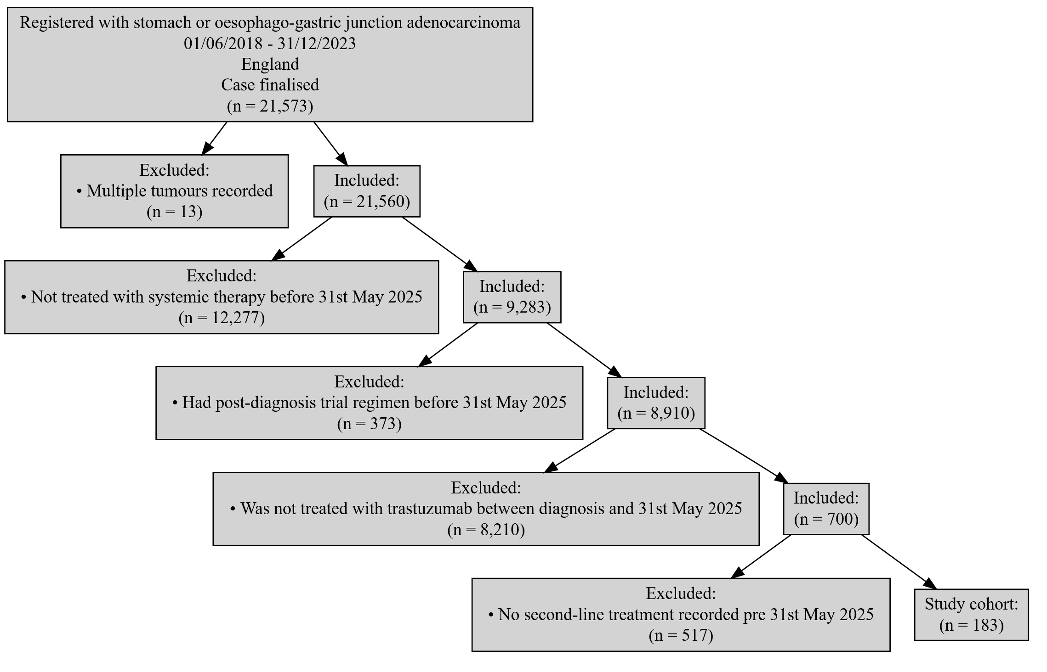
Figure 1: Inclusion / Exclusion Flow Chart

Patient acknowledgement
This work uses data that has been provided by patients and collected by the NHS as part of their care and support. The data is collated, maintained and quality assured by the National Cancer Registration and Analysis Service, which is part of NHS England.

Results

Age at start of treatment
The table below sets out the mean age, standard deviation, median age and interquartile range (IQR) of patients who have received any inferred second line treatment for HER2-positive gastric or gastroesophageal junction adenocarcinoma. Age is measured at the commencement of the second-line treatment regimen.

Characteristic | Female N = 42¹ | Male N = 141¹
Age at start of regimen | 65, (11) : 67 (57, 74) | 65, (12) : 68 (58, 73)
¹Mean, (SD) : Median (Q1, Q3)
Table 1: Mean age, standard deviation, median age and IQR of patients who have received any second line treatment

Overall survival

Base K-M plot
The Kaplan-Meier plot below shows survival over time for those receiving a second-line regimen after prior treatment with trastuzumab.
Median survival was 6.18 months. Restricted mean survival (over the whole curve) was 8.88 months. The minimum follow-up time was 0.5 months, median 6.2 months, and maximum follow-up time of 50.8 months.
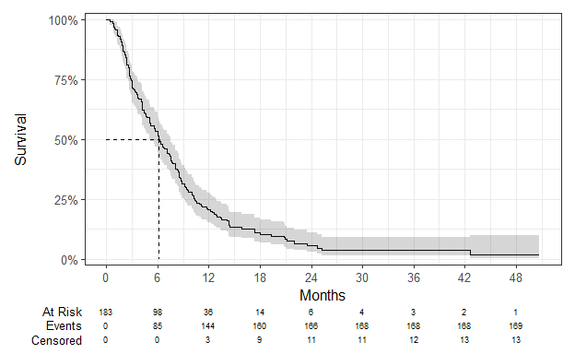
Figure 2: Overall survival amongst patients who have received second line treatment after trastuzumab

Exponential
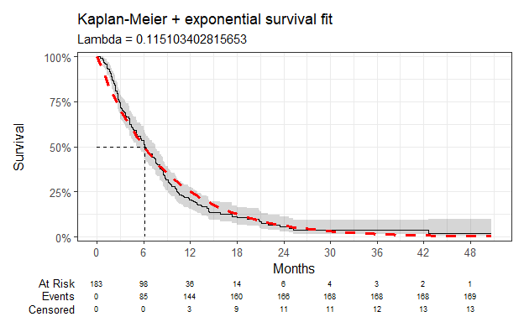
Figure 3: Overall survival against exponential survival function

Parameter | Estimate | Std. Error | z | p-value
(Intercept) | 2.162 | 0.077 | 28.10502 | 8.506316e-174
log-likelihood = -534.365223549115
AIC = 1070.73044709823
BIC = 1073.93993325107
Table 2: Survival model fit summary (exponential distribution)

Weibull
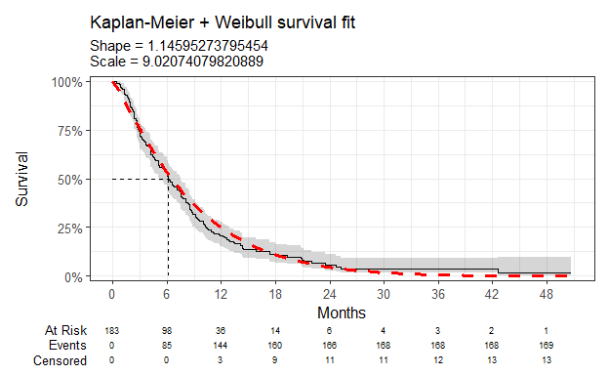
Figure 4: Overall survival against Weibull survival function

Parameter | Estimate | Std. Error | z | p-value
(Intercept) | 2.200 | 0.069 | 31.718442 | 8.652454e-221
Log(scale) | -0.136 | 0.058 | -2.354503 | 1.854748e-02
log-likelihood = -531.801385087805
AIC = 1067.60277017561
BIC = 1074.02174248129
Table 3: Survival model fit summary (Weibull distribution)

Log-normal
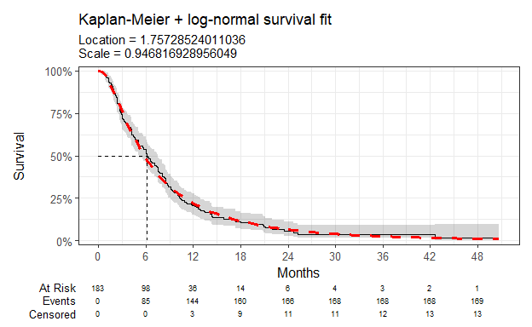
Figure 5: Overall survival against log-normal survival function

Parameter | Estimate | Std. Error | z | p-value
(Intercept) | 1.757 | 0.071 | 24.8993332 | 7.564925e-137
Log(scale) | -0.055 | 0.055 | -0.9878478 | 3.232272e-01
log-likelihood = -521.300825941116
AIC = 1046.60165188223
BIC = 1053.02062418792
Table 4: Survival model fit summary (log-normal distribution)

Log-logistic
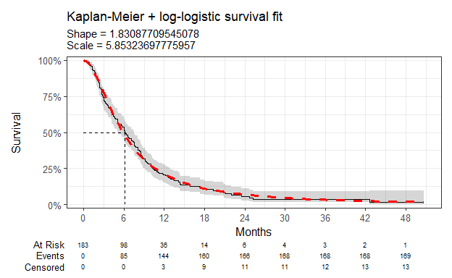
Figure 6: Overall survival against log-logistic survival function

Parameter | Estimate | Std. Error | z | p-value
(Intercept) | 1.767 | 0.071 | 25.054779 | 1.548544e-138
Log(scale) | -0.605 | 0.064 | -9.512119 | 1.868171e-21
log-likelihood = -522.117762229275
AIC = 1048.23552445855
BIC = 1054.65449676423
Table 5: Survival model fit summary (log-logistic distribution)

Gaussian
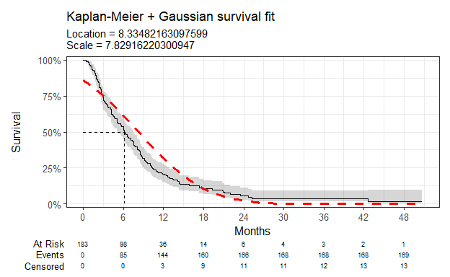
Figure 7: Overall survival against Gaussian survival function

Parameter | Estimate | Std. Error | z | p-value
(Intercept) | 8.335 | 0.584 | 14.27874 | 2.969096e-46
Log(scale) | 2.058 | 0.055 | 37.20083 | 6.616261e-303
log-likelihood = -604.066207008421
AIC = 1212.13241401684
BIC = 1218.55138632252
Table 6: Survival model fit summary (Gaussian distribution)

Gamma
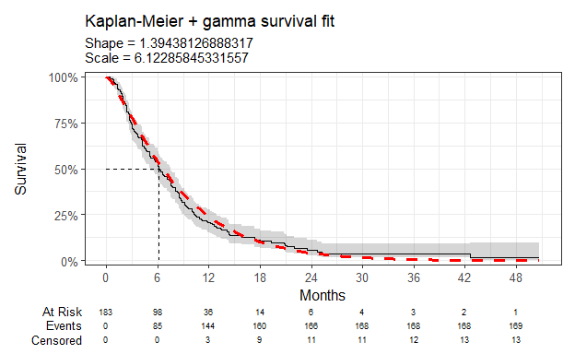
Figure 8: Overall survival against gamma survival function

Parameter | Estimate | Std. Error | L95. | U95.
shape | 1.394 | 0.137 | 1.1498850 | 1.6908640
rate | 0.163 | 0.020 | 0.1286957 | 0.2072658
log-likelihood = -529.128446320623
AIC = 1062.25689264125
BIC = 1068.67586494693
Table 7: Survival model fit summary (gamma distribution)

Generalised gamma
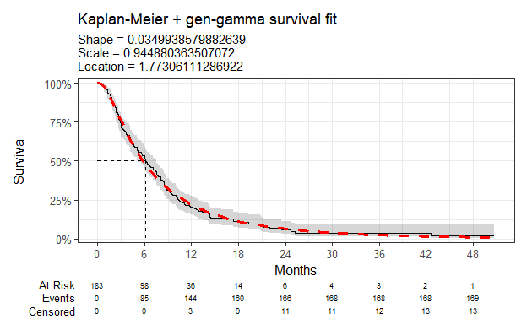
Figure 9: Overall survival against generalised gamma survival function

Parameter | Estimate | Std. Error | L95. | U95.
mu | 1.773 | 0.118 | 1.5419413 | 2.0041809
sigma | 0.945 | 0.054 | 0.8453552 | 1.0561228
Q | 0.035 | 0.210 | -0.3764649 | 0.4464527
log-likelihood = -521.286945813809
AIC = 1048.57389162762
BIC = 1058.20235008614
Table 8: Survival model fit summary (generalised gamma distribution)

Gompertz
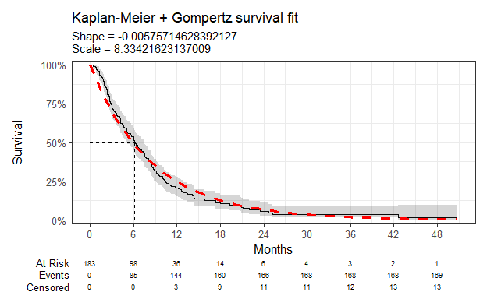
Figure 10: Overall survival against Gompertz survival function

Parameter | Estimate | Std. Error | L95. | U95.
shape | -0.006 | 0.010 | -0.02590593 | 0.01439164
rate | 0.120 | 0.013 | 0.09753604 | 0.14760646
log-likelihood = -534.203194856289
AIC = 1072.40638971258
BIC = 1078.82536201826
Table 9: Survival model fit summary (Gompertz distribution)

Second line treatment counts
The table below sets out the observed counts of each inferred second line treatment.

Second Line Treatment | N = 183¹
PACLITAXEL | 81 (44%)
DOCETAXEL | 61 (33%)
FOLFIRI | 20 (11%)
IRINOTECAN | 9 (4.9%)
PACLITAXEL + RAMUCIRUMAB | 4 (2.2%)
OTHER | 8 (4.4%)
¹n (%)
Table 10: Counts of second-line treatments after trastuzumab-based first-line treatment

Chloe J. Bright et al., “Data Resource Profile: The Systemic Anti-Cancer Therapy (SACT) dataset,” International Journal of Epidemiology 49, no. 1 (February 2020): 15–15l, https://dx.doi.org/10.1093/ije/dyz137.
NICE health technology evaluations: the manual (2025) NICE process and methods PMG36. Last updated 23 October 2025, n.d., https://www.nice.org.uk/process/pmg36.
Latimer Nicholas, NICE DSU Technical Support Document 14: Undertaking survival analysis for economic evaluations alongside clinical trials - extrapolation with patient-level data, 2011, http://www.nicedsu.org.uk/.

