NDRS-NICE partnership report

Background
This report was produced in partnership by the National Disease and Registration Service (NDRS) and National Institute for Health and Care Excellence (NICE). NDRS and NICE have established a partnership focused on routinely collected data to support NICE decision making on the appraisals of cancer treatments. The partnership uses NDRS datasets, including the information submitted by trusts to the Systemic Anti-Cancer Therapy (SACT) dataset, to provide an understanding of current practice.
This partnership is focused on producing demographic and survival information using NDRS data, alongside supplementary information tailored to each technology appraisal. These may include, for example, the time patients spend on particular treatments, genetic data where this is available, or other information on real-world care pathways. An important part of the partnership is to provide information for the severity modifiers that NICE uses for appraisals of cancer drugs. To determine severity modifiers, NICE considers factors such as the age, gender, and overall survival of the patient cohort affected by the disease.
Interpretation of the data is not included in this report, it is the information as provided to the NICE technology appraisal committees.
Detail on how NICE health technology appraisals use this data can be found in the NICE health technology evaluations manual, with specific information relating to the survival analysis modelling available in Technical Support Document (TSD).
The focus of this report is the indication ID6304: Tislelizumab for untreated recurrent or metastatic nasopharyngeal cancer
Three cohorts were assessed for this indication:
- Cohort 1: People with untreated metastatic nasopharyngeal cancer receiving first-line treatment with a systemic chemotherapy (pooled chemotherapy cohort)
- Cohort 2: People with untreated metastatic nasopharyngeal cancer receiving first-line treatment with gemcitabine plus a platinum-based therapy (gem-platinum cohort)
- Cohort 3: People with untreated metastatic nasopharyngeal cancer receiving first-line treatment with a systemic chemotherapy, excluding individuals treated with gemcitabine plus a platinum-based therapy (non-gem-platinum cohort)

Age, gender and overall survival for people with untreated metastatic nasopharyngeal cancer

Introduction
This report was produced in partnership by the National Disease and Registration Service (NDRS) and National Institute for Health and Care Excellence (NICE). It presents demographic information, overall survival and time-on-treatment among people with untreated metastatic nasopharyngeal cancer receiving first-line treatment with chemotherapy.

Method
A snapshot of SACT data was taken on 8th June 2026 and made available for analysis on 25th June 2026. SACT data is only considered complete when 90% of trusts have submitted data, which at the time of analysis was 31st August 2025. This date is used as the upper limit when selecting regimens of interest. Patients were traced for their vital status on 5th April 2026, which is the censoring date for the overall survival analysis.
Descriptive statistics of age and gender were computed, along with Kaplan-Meier estimates and parametric fits for overall survival. Patients were censored at the date of the most recent trace (5th April 2026), representing the last date on which vital status was confirmed.
Time-on-treatment was measured (cohort 2 only) by the difference between a patient’s first and last gemcitabine or carboplatin/cisplatin administration date, plus an additional 13 days to account for completion of a 21-day treatment cycle, assuming that gemcitabine has been delivered on day 8 of the cycle. If an individual died before the end date of the current treatment cycle, the treatment end date was revised to their date of death. If the patient’s treatment end date extended beyond the treatment censoring date (31st August 2025), the patient is censored.

Cohort inclusions / exclusions
Patients were included if they met all of the following:
- Diagnosed with nasopharyngeal cancer between 1st April 2013 and 31st December 2023
- Gender recorded as male or female
- Country code was England, based on postcode of residence at diagnosis
- ICD-10 diagnosis code was in the C11 category (malignant neoplasm of nasopharynx), including all four-character subcategories
- Only one nasopharyngeal tumour was recorded during the study period
- No registration for another malignant neoplasm within the 36 months preceding diagnosis (inclusive of the nasopharyngeal cancer diagnosis date)
- Metastatic disease (stage 4) as diagnosis
- First line treatment following diagnosis was not given as part of a clinical trial
- Were untreated, as only first-line treatments following diagnosis were considered. Eligible therapies included gemcitabine, cisplatin, carboplatin, flurouracil, docetaxel, paclitaxel, capecitabine, as well as all combination regimens containing at least one of these agents
- Met the cohort specific treatment criteria:
  - Cohort 1 (pooled chemotherapy cohort): received first-line treatment following diagnosis with any eligible therapy listed above
  - Cohort 2 (gem-platinum cohort): received first-line treatment following diagnosis with gemcitabine in combination with a platinum-based therapy (cisplatin, carboplatin)
  - Cohort 3 (non-gem-platinum cohort): received first-line treatment following diagnosis with an eligible therapy included in cohort 1, excluding individuals from cohort 2
Note: It was not possible to include individuals with recurrent disease, as information on recurrence is not yet routinely available.

Radiotherapy use
We investigated radiotherapy use among individuals diagnosed with metastatic nasopharyngeal cancer who received a subsequent SACT therapy (Cohort 1 - pooled chemotherapy cohort). To do this we linked to existing data on cancer treatments, which is available for tumours diagnosed between 2013 an 2022. Of the 401 individuals diagnosed during this period, 361 (89.8%) had a record of radiotherapy during the available follow-up, indicating that radiotherapy remains a commonly used component of care in this population.

Sensitivity analyses
To assess the robustness of the study findings, a series of sensitivity analyses were conducted. These analyses examined the impact of varying the inclusion and exclusion criteria used to define the study population, and how these variations influenced both the size of the study population and the estimated overall survival.
The table below summarises the sensitivity analyses undertaken and their corresponding effects on population size and overall survival estimates.
Cohort | Assumption | Population | N | Median survival | Restricted mean survival (Whole curve)
Cohort 1 (base population) | - | Base population: NPC diagnosis, stage 4 at diagnosis, first-line treatment was among those detailed in inclusion/exclusion criteria | 470 | Not reached | 76.53 months
Cohort 1 | Exclusion of other neoplasms | Base population, but removing the exclusion of prior neoplasms within 36 months (relaxed population) | 479 | 102.28 months | 75.97 months
Cohort 1 | Staging at diagnosis | Base population, but including individuals with stage 3/4 disease at diagnosis (relaxed population) | 806 | Not reached | 85.04 months
Cohort 1 | Expected first-line treatments | Base population, but allowing any first-line treatment, excluding regimens recorded as 'not chemo', 'zoledronic acid', 'hormones' or 'not matched' (relaxed population) | 487 | 102.28 months | 75.16 months
Cohort 2 (base population) | - | Base population: NPC diagnosis, stage 4 at diagnosis, first-line treatment was among those detailed in inclusion/exclusion criteria | 133 | Not reached | 55.67 months
Cohort 2 | Exclusion of other neoplasms | Base population, but removing the exclusion of prior neoplasms within 36 months (relaxed population) | 135 | Not reached | 56.02 months
Cohort 2 | Staging at diagnosis | Base population, but including individuals with stage 3/4 disease at diagnosis (relaxed population) | 197 | Not reached | 59.59 months
Cohort 2 | Expected first-line treatments | Base population, but allowing any first-line treatment, excluding regimens recorded as 'not chemo', 'zoledronic acid', 'hormones' or 'not matched' (relaxed population) | 130 | Not reached | 55.65 months
Cohort 3 (base population) | - | Base population: NPC diagnosis, stage 4 at diagnosis, first-line treatment was among those detailed in inclusion/exclusion criteria | 337 | 102.28 months | 76.13 months
Cohort 3 | Exclusion of other neoplasms | Base population, but removing the exclusion of prior neoplasms within 36 months (relaxed population) | 344 | 102.28 months | 75.17 months
Cohort 3 | Staging at diagnosis | Base population, but including individuals with stage 3/4 disease at diagnosis (relaxed population) | 609 | Not reached | 85.49 months
Cohort 3 | Expected first-line treatments | Base population, but allowing any first-line treatment, excluding regimens recorded as 'not chemo', 'zoledronic acid', 'hormones' or 'not matched' (relaxed population) | 357 | 100.63 months | 74.26 months
Table 1: Sensitivity analyses

Flow chart
Figure 1: Inclusion / Exclusion Flow Chart
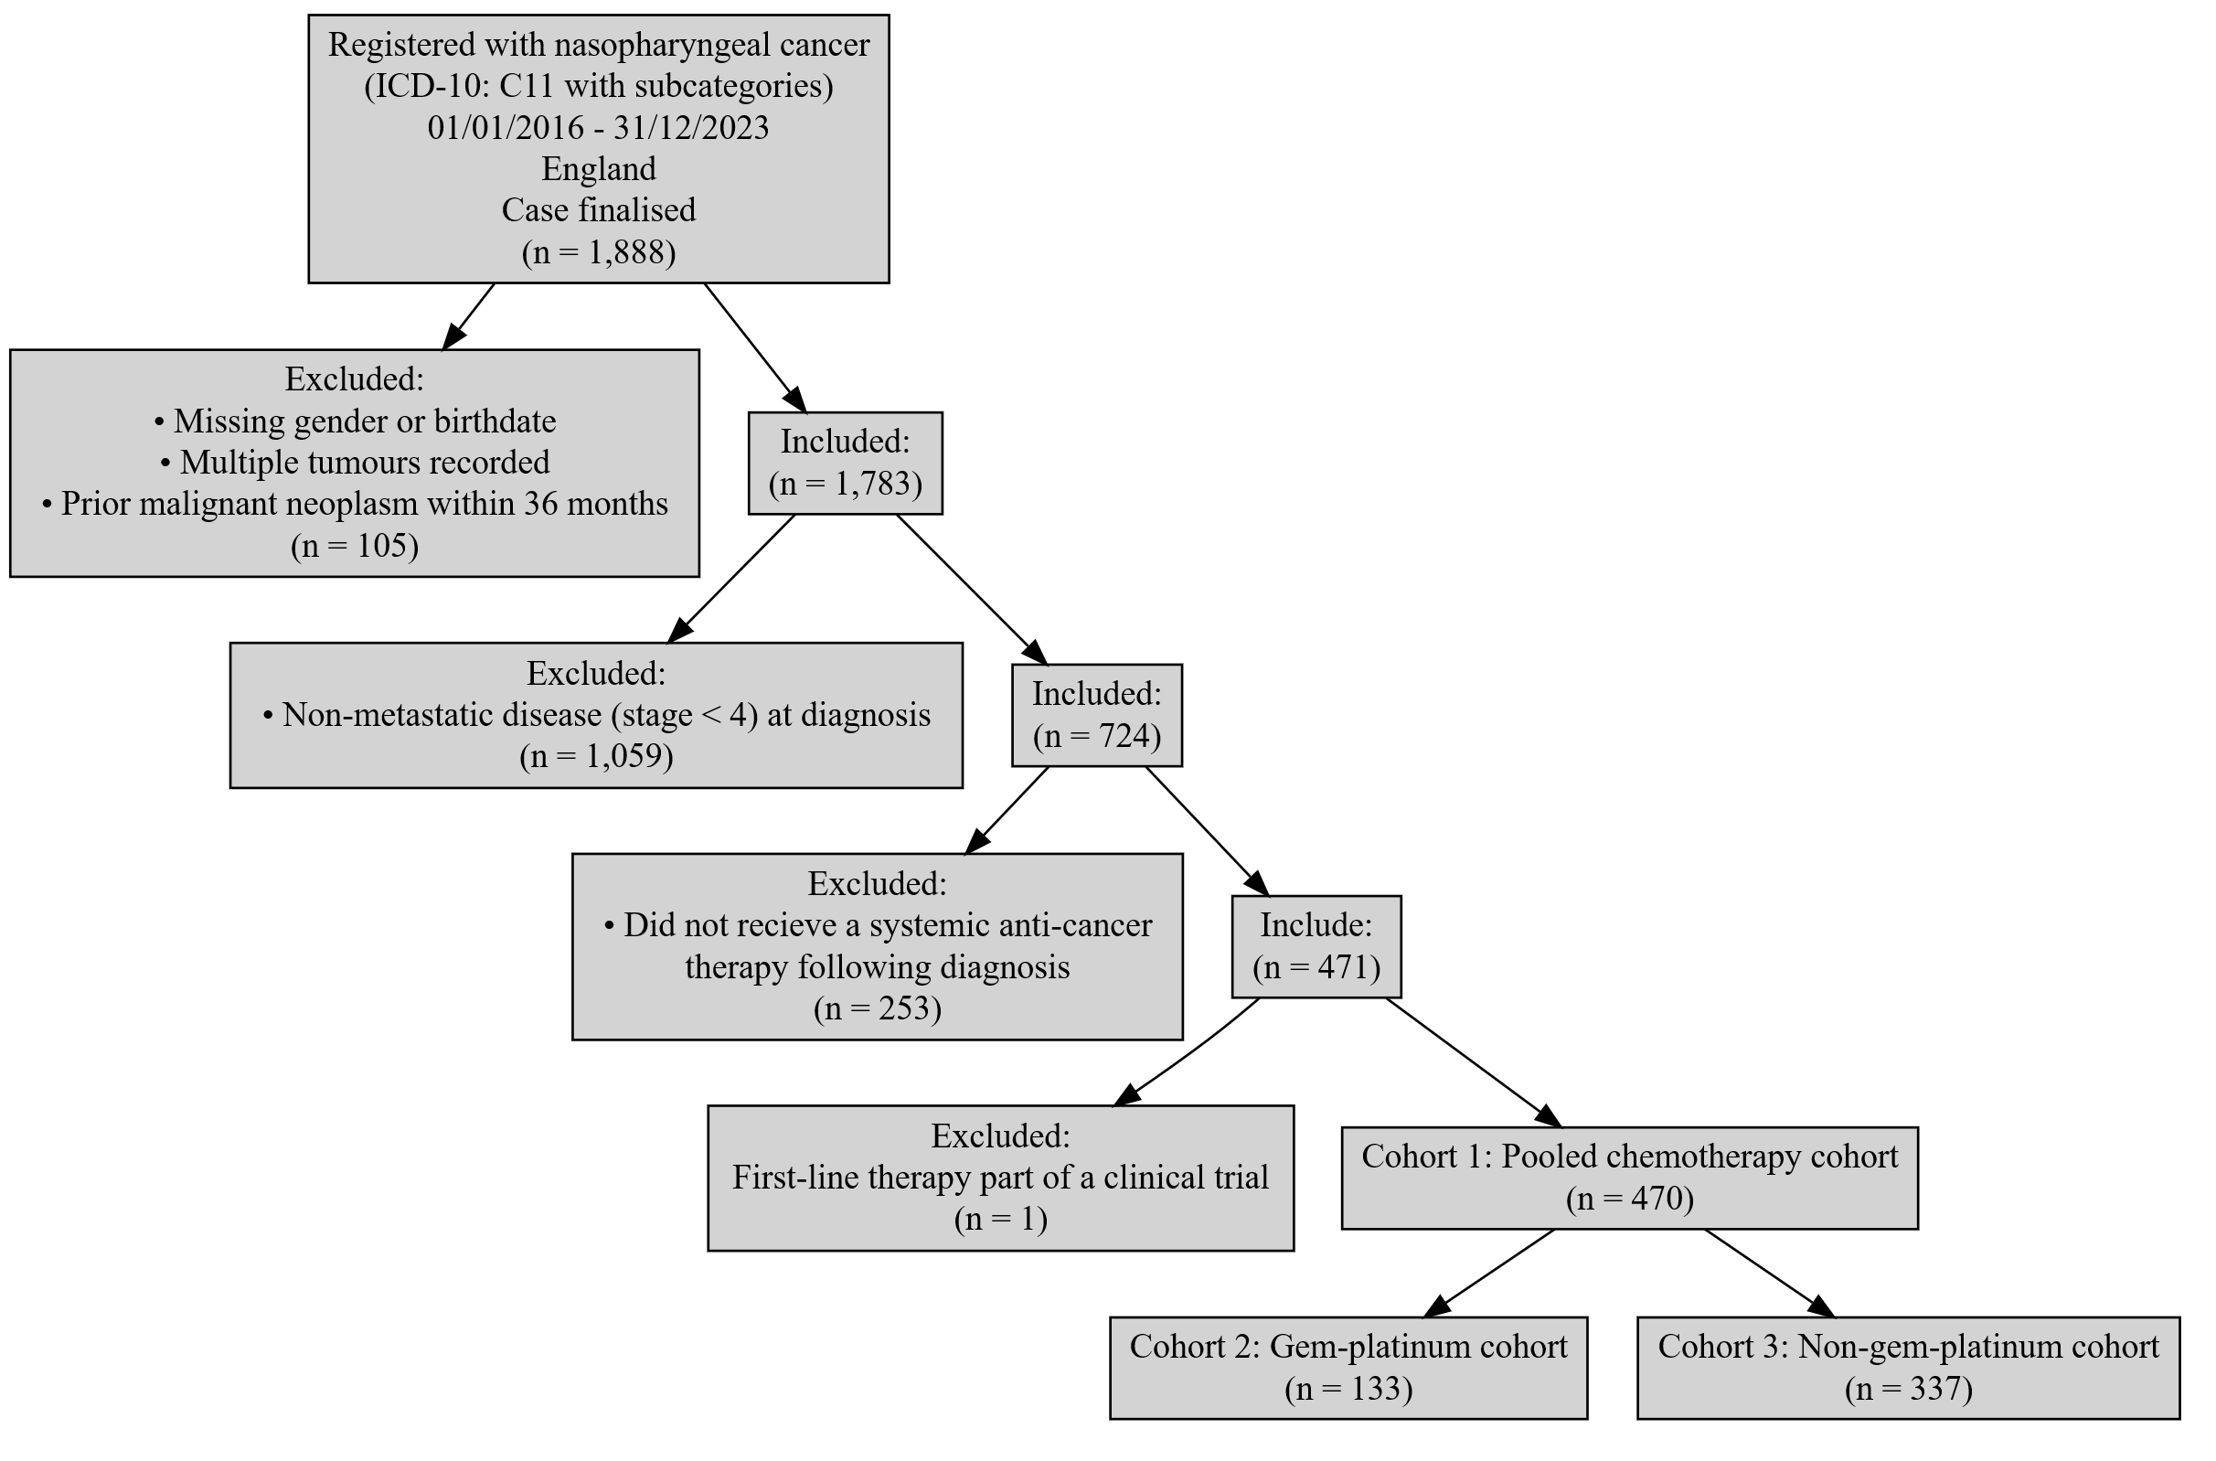

Patient acknowledgement
This work uses data that has been provided by patients and collected by the NHS as part of their care and support. The data is collated, maintained and quality assured by the National Cancer Registration and Analysis Service, which is part of NHS England.

Results - first-line treatment counts
The table below shows the number of individuals receiving each first-line treatment following diagnosis with metastatic (stage 4) nasopharyngeal cancer. The total number of treatment initiations slightly exceeds the cohort size because two individuals commenced more than one first-line regimen on the same day and were therefore captured in multiple treatment categories.
First-line treatment | N = 472¹
CISPLATIN + FLUOROURACIL | 143 (30%)
CISPLATIN + GEMCITABINE | 106 (22%)
CISPLATIN + DOCETAXEL + FLUOROURACIL | 85 (18%)
CISPLATIN | 58 (12%)
CARBOPLATIN + GEMCITABINE | 27 (5.7%)
CARBOPLATIN + FLUOROURACIL | 20 (4.2%)
CARBOPLATIN | 17 (3.6%)
CAPECITABINE + CARBOPLATIN | 5 (1.1%)
OTHER | 11 (2.3%)
¹n (%)
Table 2: Count of individuals receiving each first-line treatment following diagnosis with metastatic (stage 4) nasopharyngeal cancer

Results - pooled chemotherapy (cohort 1)

Age at start of treatment
The table below sets out the mean age, standard deviation, median age and interquartile range (IQR) of patients receiving first-line treatment with a systemic chemotherapy (pooled chemotherapy cohort). Age is measured at the commencement of the first treatment regimen.
Characteristic | Female N = 113¹ | Male N = 357¹
Age at treatment start | 50, (15) : 52 (43, 62) | 53, (14) : 55 (46, 62)
¹Mean, (SD) : Median (Q1, Q3)
Table 3: Mean age, standard deviation, median age and IQR of patients receiving first-line treatment with a systemic chemotherapy (pooled chemotherapy cohort)

Overall survival

Base K-M plot
The Kaplan-Meier plot below shows survival over time for patients receiving first-line treatment with a systemic chemotherapy (pooled chemotherapy cohort).
Median survival was not reached. Restricted mean survival (over the whole curve) was 76.53 months. The minimum follow-up time was 0.9 months, median 41.5 months, and maximum follow-up time of 121.7 months.
Figure 2: Overall survival amongst patients receiving first-line treatment with a systemic chemotherapy (pooled chemotherapy cohort)
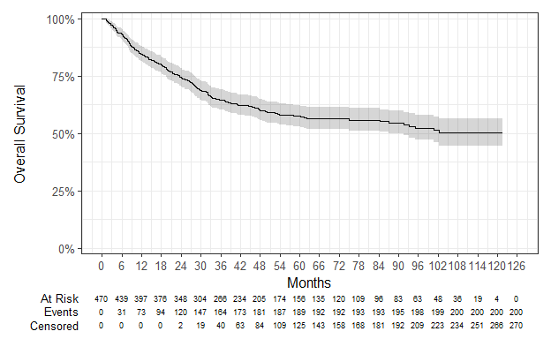

Exponential
Figure 3: Overall survival against exponential survival function
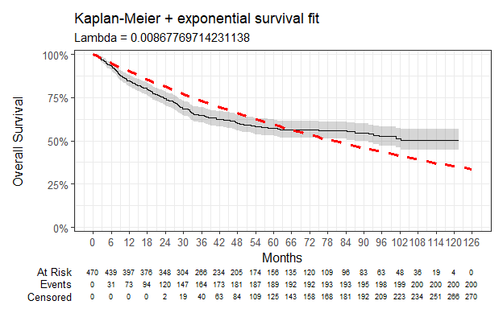

Parameter | Estimate | Std. Error | z | p-value
(Intercept) | 4.747 | 0.071 | 67.1327 | 0
log-likelihood = -1149.39981833902
AIC = 2300.79963667805
BIC = 2304.95236937275
Table 4: Survival model fit summary (exponential distribution)

Weibull
Figure 4: Overall survival against Weibull survival function
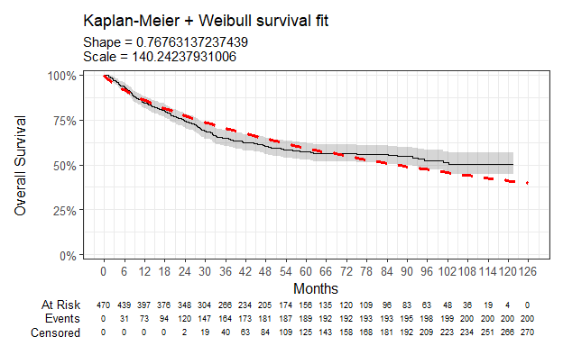

Parameter | Estimate | Std. Error | z | p-value
(Intercept) | 4.943 | 0.108 | 45.79252 | 0.000000e+00
Log(scale) | 0.264 | 0.063 | 4.19154 | 2.770677e-05
log-likelihood = -1139.55922922222
AIC = 2283.11845844444
BIC = 2291.42392383385
Table 5: Survival model fit summary (Weibull distribution)

Log-normal
Figure 5: Overall survival against log-normal survival function
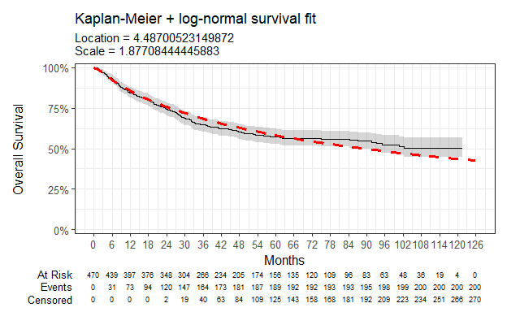

Parameter | Estimate | Std. Error | z | p-value
(Intercept) | 4.487 | 0.117 | 38.30512 | 5.039470e-321
Log(scale) | 0.630 | 0.056 | 11.17146 | 5.624782e-29
log-likelihood = -1126.00789938918
AIC = 2256.01579877837
BIC = 2264.32126416778
Table 6: Survival model fit summary (log-normal distribution)

Log-logistic
Figure 6: Overall survival against log-logistic survival function
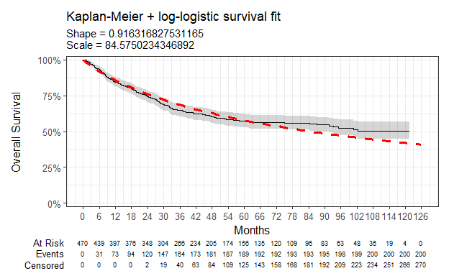

Parameter | Estimate | Std. Error | z | p-value
(Intercept) | 4.438 | 0.109 | 40.836178 | 0.0000000
Log(scale) | 0.087 | 0.061 | 1.422362 | 0.1549212
log-likelihood = -1132.2658725351
AIC = 2268.5317450702
BIC = 2276.83721045961
Table 7: Survival model fit summary (log-logistic distribution)

Gaussian
Figure 7: Overall survival against Gaussian survival function
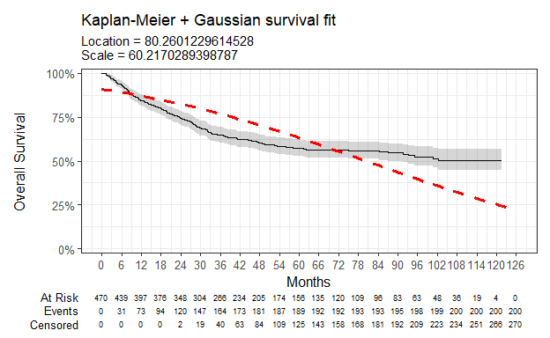

Parameter | Estimate | Std. Error | z | p-value
(Intercept) | 80.260 | 3.742 | 21.44968 | 4.598271e-102
Log(scale) | 4.098 | 0.056 | 73.21628 | 0.000000e+00
log-likelihood = -1269.50474652602
AIC = 2543.00949305205
BIC = 2551.31495844145
Table 8: Survival model fit summary (Gaussian distribution)

Gamma
Figure 8: Overall survival against gamma survival function
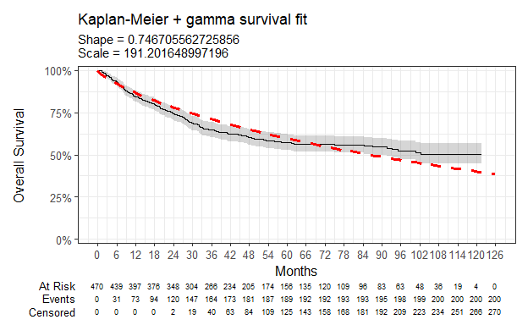

Parameter | Estimate | Std. Error | L95. | U95.
shape | 0.747 | 0.059 | 0.639865491 | 0.871385011
rate | 0.005 | 0.001 | 0.003757698 | 0.007279388
log-likelihood = -1142.03574719913
AIC = 2288.07149439826
BIC = 2296.37695978767
Table 9: Survival model fit summary (gamma distribution)

Generalised gamma
Figure 9: Overall survival against generalised gamma survival function
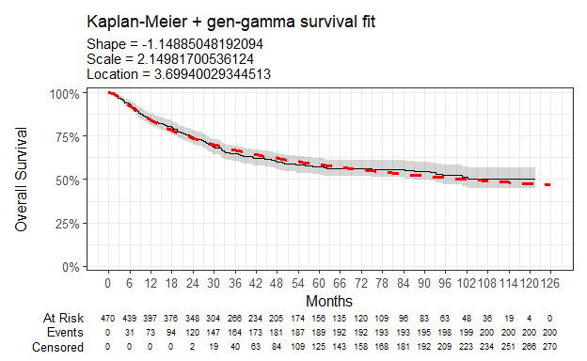

Parameter | Estimate | Std. Error | L95. | U95.
mu | 3.699 | 0.291 | 3.129569 | 4.2692319
sigma | 2.150 | 0.115 | 1.935252 | 2.3881713
Q | -1.149 | 0.347 | -1.828674 | -0.4690272
log-likelihood = -1120.82420271507
AIC = 2247.64840543014
BIC = 2260.10660351425
Table 10: Survival model fit summary (generalised gamma distribution)

Gompertz
Figure 10: Overall survival against Gompertz survival function
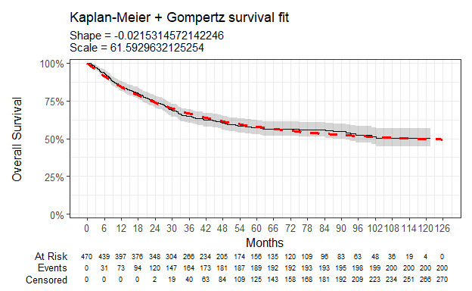

Parameter | Estimate | Std. Error | L95. | U95.
shape | -0.022 | 0.003 | -0.02816976 | -0.01489315
rate | 0.016 | 0.002 | 0.01319140 | 0.01998237
log-likelihood = -1124.41383705362
AIC = 2252.82767410725
BIC = 2261.13313949665
Table 11: Survival model fit summary (Gompertz distribution)

Results - gemcitabine plus a platinum-based therapy (cohort 2)

Age at start of treatment
The table below sets out the mean age, standard deviation, median age and interquartile range (IQR) of patients receiving first-line treatment with gemcitabine plus a platinum-based therapy (gem-platinum cohort). Age is measured at the commencement of the first treatment regimen.
Characteristic | Female N = 28¹ | Male N = 105¹
Age at treatment start | 52, (15) : 55 (43, 64) | 53, (13) : 54 (46, 60)
¹Mean, (SD) : Median (Q1, Q3)
Table 12: Mean age, standard deviation, median age and IQR of patients receiving first-line treatment with gemcitabine plus a platinum-based therapy (gem-platinum cohort)

Overall survival

Base K-M plot
The Kaplan-Meier plot below shows survival over time for patients receiving first-line treatment with gemcitabine plus a platinum-based therapy (gem-platinum cohort).
Median survival was not reached. Restricted mean survival (over the whole curve) was 55.67 months. The minimum follow-up time was 1.2 months, median 34.7 months, and maximum follow-up time of 80.2 months.
Figure 11: Overall survival amongst patients receiving first-line treatment with gemcitabine plus a platinum-based therapy (gem-platinum cohort)
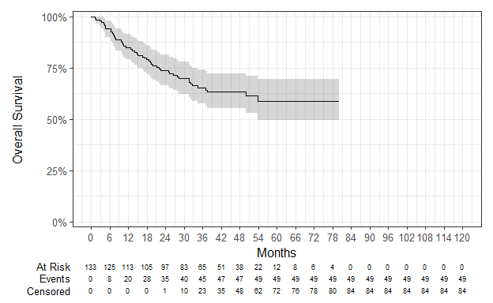

Exponential
Figure 12: Overall survival against exponential survival function
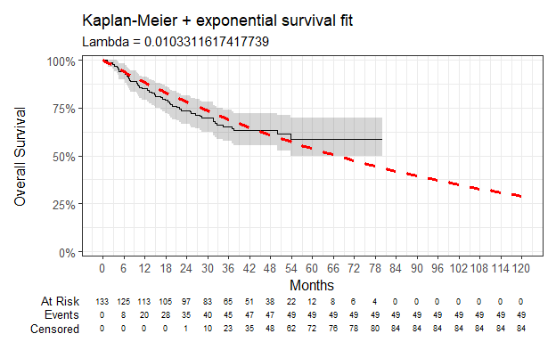

Parameter | Estimate | Std. Error | z | p-value
(Intercept) | 4.573 | 0.143 | 32.00813 | 8.402893e-225
log-likelihood = -273.056936507395
AIC = 548.11387301479
BIC = 551.004222143012
Table 13: Survival model fit summary (exponential distribution)

Weibull
Figure 13: Overall survival against Weibull survival function
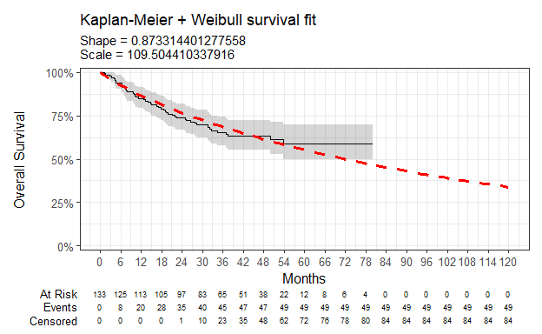

Parameter | Estimate | Std. Error | z | p-value
(Intercept) | 4.696 | 0.209 | 22.514749 | 2.976217e-112
Log(scale) | 0.135 | 0.131 | 1.035614 | 3.003824e-01
log-likelihood = -272.490675694656
AIC = 548.981351389312
BIC = 554.762049645756
Table 14: Survival model fit summary (Weibull distribution)

Log-normal
Figure 14: Overall survival against log-normal survival function
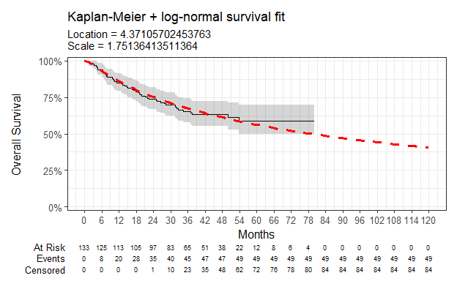

Parameter | Estimate | Std. Error | z | p-value
(Intercept) | 4.371 | 0.226 | 19.302039 | 5.163087e-83
Log(scale) | 0.560 | 0.116 | 4.843451 | 1.276031e-06
log-likelihood = -269.705584021534
AIC = 543.411168043069
BIC = 549.191866299512
Table 15: Survival model fit summary (log-normal distribution)

Log-logistic
Figure 15: Overall survival against log-logistic survival function
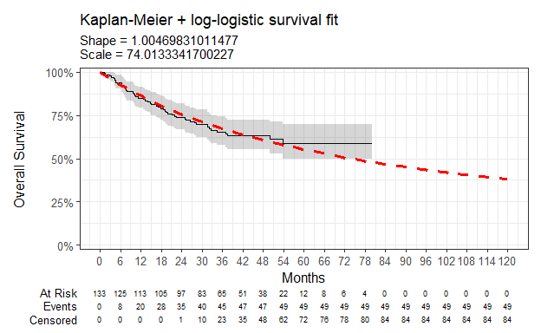

Parameter | Estimate | Std. Error | z | p-value
(Intercept) | 4.304 | 0.204 | 21.06823877 | 1.556124e-98
Log(scale) | -0.005 | 0.127 | -0.03696797 | 9.705105e-01
log-likelihood = -271.190600645785
AIC = 546.381201291569
BIC = 552.161899548013
Table 16: Survival model fit summary (log-logistic distribution)

Gaussian
Figure 16: Overall survival against Gaussian survival function
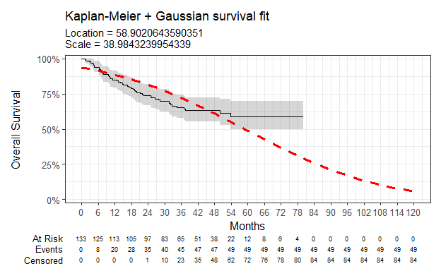

Parameter | Estimate | Std. Error | z | p-value
(Intercept) | 58.902 | 5.021 | 11.73107 | 8.833423e-32
Log(scale) | 3.663 | 0.116 | 31.67271 | 3.691812e-220
log-likelihood = -296.549897306344
AIC = 597.099794612688
BIC = 602.880492869131
Table 17: Survival model fit summary (Gaussian distribution)

Gamma
Figure 17: Overall survival against gamma survival function
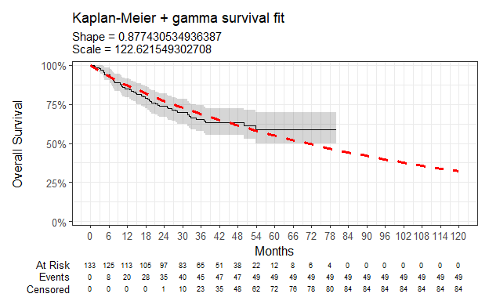

Parameter | Estimate | Std. Error | L95. | U95.
shape | 0.877 | 0.142 | 0.638905452 | 1.2050051
rate | 0.008 | 0.003 | 0.004195354 | 0.0158525
log-likelihood = -272.721205551563
AIC = 549.442411103125
BIC = 555.223109359569
Table 18: Survival model fit summary (gamma distribution)

Generalised gamma
Figure 18: Overall survival against generalised gamma survival function
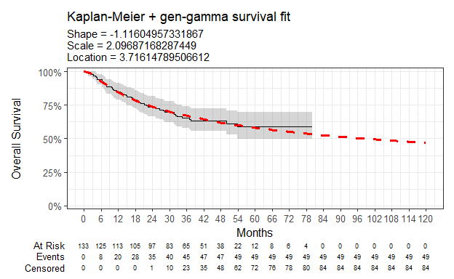

Parameter | Estimate | Std. Error | L95. | U95.
mu | 3.716 | 0.584 | 2.571971 | 4.8603245
sigma | 2.097 | 0.243 | 1.671586 | 2.6303581
Q | -1.116 | 0.779 | -2.642950 | 0.4108513
log-likelihood = -268.709098482133
AIC = 543.418196964265
BIC = 552.089244348931
Table 19: Survival model fit summary (generalised gamma distribution)

Gompertz
Figure 19: Overall survival against Gompertz survival function
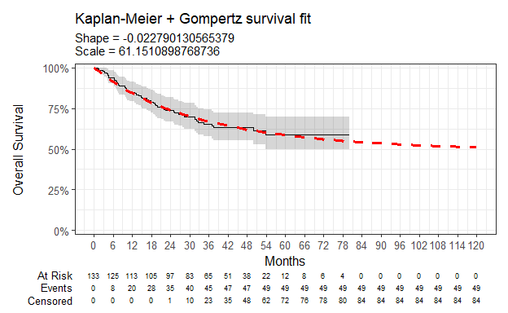

Parameter | Estimate | Std. Error | L95. | U95.
shape | -0.023 | 0.010 | -0.04264507 | -0.002935193
rate | 0.016 | 0.004 | 0.01044657 | 0.025598698
log-likelihood = -270.233476986408
AIC = 544.466953972817
BIC = 550.24765222926
Table 20: Survival model fit summary (Gompertz distribution)

Time on treatment - Gemcitabine plus carboplatin/cisplatin
The Kaplan-Meier plot below shows time-on-treatment (TOT) for patients receiving gemcitabine plus carboplatin/cisplatin. The median TOT was 2.04 months, CI (2.04 months, 2.07 months). One individual had a recorded TOT of approximately 20 months, reflecting two distinct treatment periods separated by 14 months during the COVID-19 pandemic. As all treatment administrations were recorded under a single regimen, this individual was retained in the primary analysis. To assess the impact of this outlier on the results, a sensitivity analysis excluding the individual was also performed, with median TOT and confidence intervals remaining unchanged.
Figure 20: Time-on-treatment for patients receiving first-line treatment with gemcitabine plus a platinum-based therapy
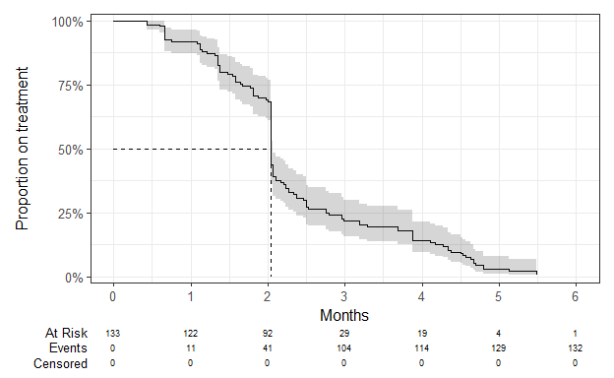

Results - pooled chemotherapy, excluding individuals treated with gemcitabine plus a platinum-based therapy (cohort 3)

Age at start of treatment
The table below sets out the mean age, standard deviation, median age and interquartile range (IQR) of patients receiving first-line treatment with a systemic chemotherapy, excluding individuals treated with gemcitabine plus a platinum-based therapy (non-gem-platinum cohort). Age is measured at the commencement of the first treatment regimen.
Characteristic | Female N = 85¹ | Male N = 252¹
Age at treatment start | 49, (15) : 52 (44, 62) | 54, (14) : 55 (47, 63)
¹Mean, (SD) : Median (Q1, Q3)
Table 21: Mean age, standard deviation, median age and IQR of patients receiving first-line treatment with a systemic chemotherapy, excluding individuals treated with gemcitabine plus a platinum-based therapy (non-gem-platinum cohort)

Overall survival

Base K-M plot
The Kaplan-Meier plot below shows survival over time for patients receiving first-line treatment with a systemic chemotherapy, excluding individuals treated with gemcitabine plus a platinum-based therapy (non-gem-platinum cohort).
Median survival was 102.28 months. Restricted mean survival (over the whole curve) was 76.13 months. The minimum follow-up time was 0.9 months, median 47.8 months, and maximum follow-up time of 121.7 months.
Figure 21: Overall survival amongst patients receiving first-line treatment with a systemic chemotherapy, excluding individuals treated with gemcitabine plus a platinum-based therapy (non-gem-platinum cohort)
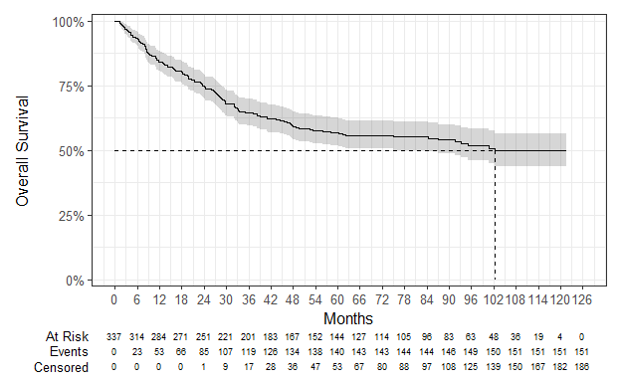

Exponential
Figure 22: Overall survival against exponential survival function
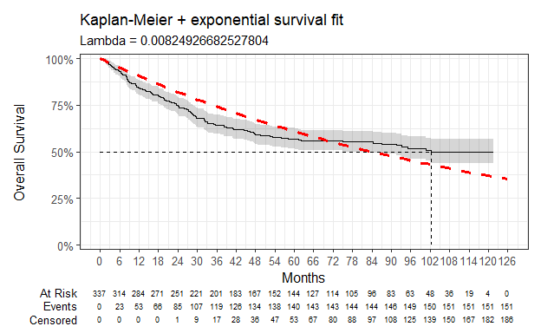

Parameter | Estimate | Std. Error | z | p-value
(Intercept) | 4.798 | 0.081 | 58.95428 | 0
log-likelihood = -875.442274222132
AIC = 1752.88454844426
BIC = 1756.70463137462
Table 22: Survival model fit summary (exponential distribution)

Weibull
Figure 23: Overall survival against Weibull survival function
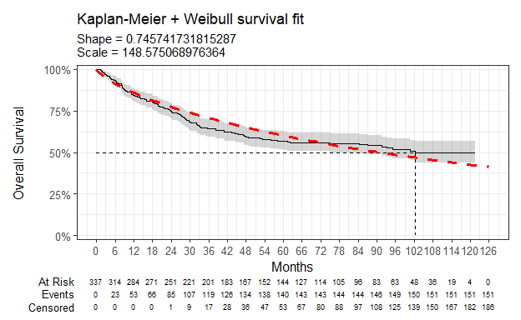

Parameter | Estimate | Std. Error | z | p-value
(Intercept) | 5.001 | 0.126 | 39.831626 | 0.000000e+00
Log(scale) | 0.293 | 0.073 | 4.020593 | 5.805175e-05
log-likelihood = -866.308443289865
AIC = 1736.61688657973
BIC = 1744.25705244043
Table 23: Survival model fit summary (Weibull distribution)

Log-normal
Figure 24: Overall survival against log-normal survival function
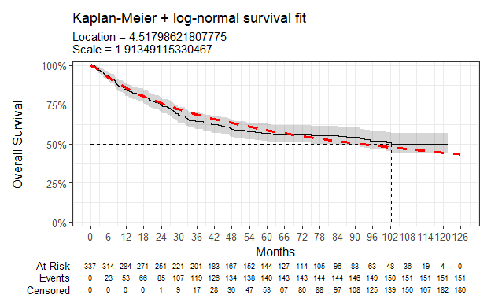

Parameter | Estimate | Std. Error | z | p-value
(Intercept) | 4.518 | 0.137 | 33.07323 | 7.212514e-240
Log(scale) | 0.649 | 0.065 | 10.01657 | 1.288942e-23
log-likelihood = -856.068979883122
AIC = 1716.13795976624
BIC = 1723.77812562695
Table 24: Survival model fit summary (log-normal distribution)

Log-logistic
Figure 25: Overall survival against log-logistic survival function
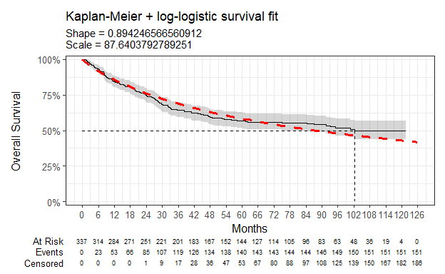

Parameter | Estimate | Std. Error | z | p-value
(Intercept) | 4.473 | 0.127 | 35.08499 | 1.141991e-269
Log(scale) | 0.112 | 0.071 | 1.58302 | 1.134168e-01
log-likelihood = -860.711828329023
AIC = 1725.42365665805
BIC = 1733.06382251875
Table 25: Survival model fit summary (log-logistic distribution)

Gaussian
Figure 26: Overall survival against Gaussian survival function
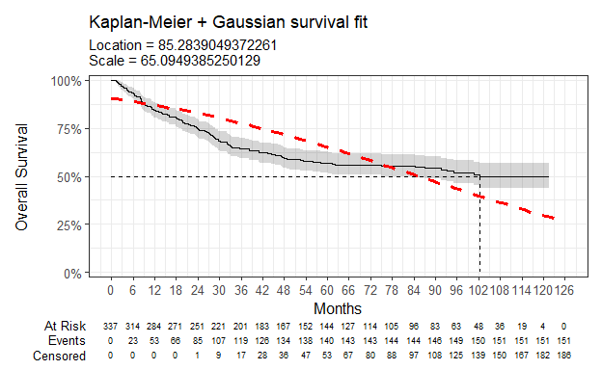

Parameter | Estimate | Std. Error | z | p-value
(Intercept) | 85.284 | 4.632 | 18.41166 | 1.059275e-75
Log(scale) | 4.176 | 0.065 | 64.37637 | 0.000000e+00
log-likelihood = -965.798966323346
AIC = 1935.59793264669
BIC = 1943.2380985074
Table 26: Survival model fit summary (Gaussian distribution)

Gamma
Figure 27: Overall survival against gamma survival function
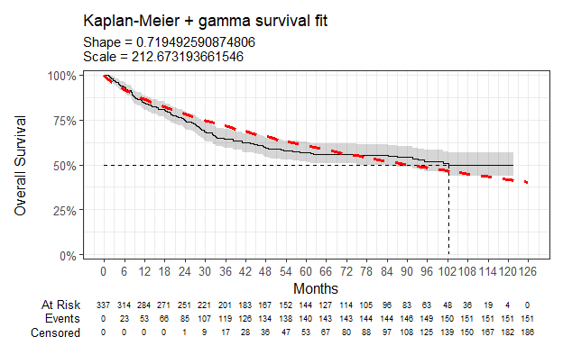

Parameter | Estimate | Std. Error | L95. | U95.
shape | 0.719 | 0.066 | 0.601779423 | 0.860231455
rate | 0.005 | 0.001 | 0.003209644 | 0.006888388
log-likelihood = -868.397158796379
AIC = 1740.79431759276
BIC = 1748.43448345346
Table 27: Survival model fit summary (gamma distribution)

Generalised gamma
Figure 28: Overall survival against generalised gamma survival function
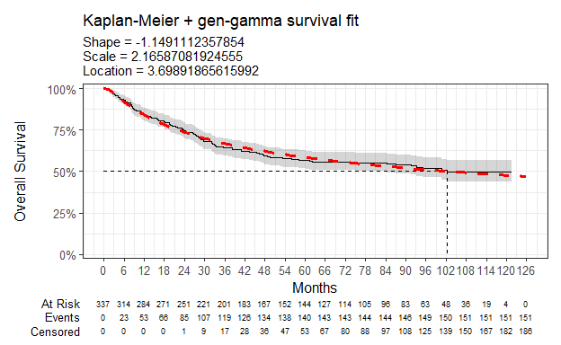

Parameter | Estimate | Std. Error | L95. | U95.
mu | 3.699 | 0.339 | 3.034518 | 4.3633193
sigma | 2.166 | 0.133 | 1.920108 | 2.4430895
Q | -1.149 | 0.392 | -1.917556 | -0.3806667
log-likelihood = -852.07254498883
AIC = 1710.14508997766
BIC = 1721.60533876872
Table 28: Survival model fit summary (generalised gamma distribution)

Gompertz
Figure 29: Overall survival against Gompertz survival function
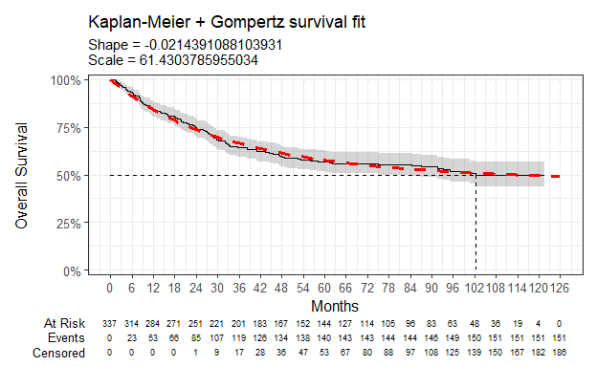

Parameter | Estimate | Std. Error | L95. | U95.
shape | -0.021 | 0.004 | -0.02856139 | -0.01431682
rate | 0.016 | 0.002 | 0.01280837 | 0.02068902
log-likelihood = -854.164771918453
AIC = 1712.32954383691
BIC = 1719.96970969761
Table 29: Survival model fit summary (Gompertz distribution)

Chloe J. Bright et al., “Data Resource Profile: The Systemic Anti-Cancer Therapy (SACT) dataset,” International Journal of Epidemiology 49, no. 1 (February 2020): 15–15l, https://dx.doi.org/10.1093/ije/dyz137.
NICE health technology evaluations: the manual (2025) NICE process and methods PMG36. Last updated 23 October 2025, n.d., https://www.nice.org.uk/process/pmg36.
Latimer Nicholas, NICE DSU Technical Support Document 14: Undertaking survival analysis for economic evaluations alongside clinical trials - extrapolation with patient-level data, 2011, http://www.nicedsu.org.uk/.

