PDS-MESH UI Onboarding Process

The current batch tracing service is to be decommissioned and replaced by PDS-MESH, which uses MESH (Message Exchange for Social Care and Health) to obtain information from the PDS (Personal Demographics Service).

The MESH UI is a User Interface and website that can be accessed from the Internet or HSCN and does not require the installation or any software. When sending requests using this method, there is a file size limit of 50MB. Users can authenticate to their MESH UI account using 2 factor authentication (if connecting via the Internet) or using a smartcard (if connecting via HSCN).
Steps to onboard:
- Authority to access PDS data
- Request a MESH mailbox for use with the MESH UI in the Live Production environment
- Request MESH UI account linked to the MESH mailbox
(- Register 2FA if connecting over the internet)

Authority to Access PDS data
To access PDS data, you must have a clear legal basis to do so and need to complete a PDS access request form and send it to demographics@nhs.net to have your use case approved.

Request a MESH mailbox for use with the MESH UI
If you already have a MESH mailbox which is used for other purposes, an assessment needs to be made about whether this existing mailbox can be used for PDS-MESH purposes. You should complete a MESH mailbox request form if you require a mailbox.
In the request form, provide the ODS code and in the data usage section specify that you want to Initiate workflows from the Master Patient Tracing System workflow group.
For IG purposes, it is recommended that a separate mailbox is used for the sole purpose of PDS-MESH messaging, where access to it can be controlled and audited.
Once the registration is complete and approved, you will be provided with the mailbox id and asked to submit a request for a MESH UI account that’s linked to that mailbox.

Request a MESH UI Account
If you want to manage your MESH mailbox using the MESH UI will need to apply for your own MESH UI account by submitting an online form.

If you are connecting to the MESH UI over HSCN you must use a smartcard to authenticate and provide the UUID (the long number below their photo). After your MESH UI account has been created, you can login by pointing your web browser to https://portal.spineservices.nhs.uk/meshui/, authenticating with your smartcard and PIN, or by going to the Spine Portal and selecting the link to Launch the MESH User Interface.

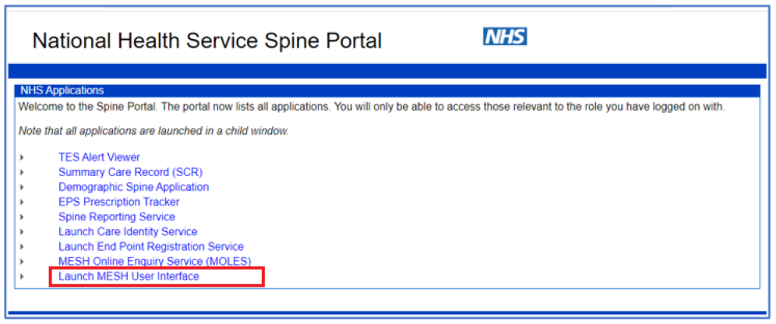
If connecting to the MESH UI over the internet, you will have to login to your account using 2-factor authentication. The MESH UI account will be registered under your NHS email address. After the MESH UI account has been created, you will first need to set up 2-factor authentication by creating a PIN and then selecting the method of receiving your one-time passwords (either through the Google Authenticator App or via email).

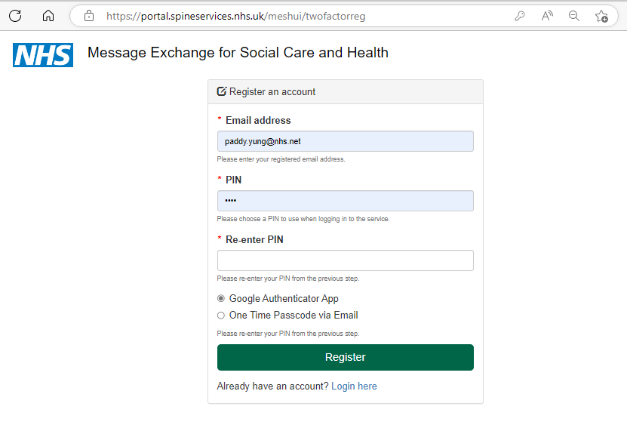

If Google Authenticator is selected, instructions containing a QR Code will be sent to you by email.
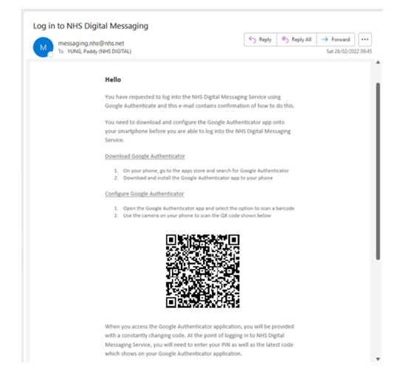
After 2FA registration, you will then be able to login using the PIN you’ve set and the one-time password (Authentication Code). The one-time password will consist of 6 digits (if obtained from the Authenticator app), or 8 digits if obtained via email. Spaces in the one-time passwords are for readability and ease of memory, and should not be typed in.
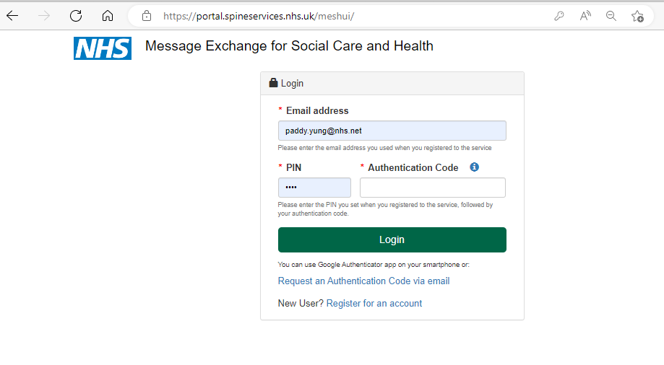

Upon successful authentication, you will be presented with a screen that looks similar to the following…

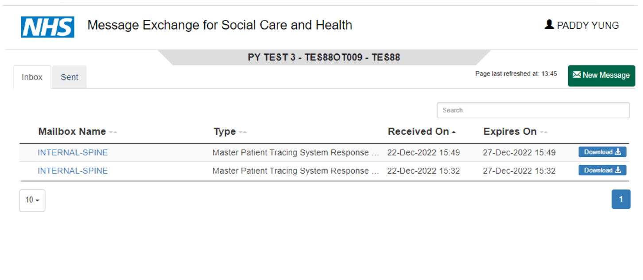

Creating the request file
The request consists of 23 fields. Not all fields can be searched on.
Column name | Maximum length | Description
UNIQUE REFERENCE | Any | Mandatory field. Client generated unique reference used as a record identifier to enable the sender to identify and correlate responses.  The following characters are not allowed:  '!', '$', '%', '&', '(', ')', '[', ']', '{','}', '=', ':', ';', '#', '~', '@', '|', '<', '>', '.', '?', '_', '\\', '£'.
NHS_NO | 10 | NHS number used to identify a person uniquely within the NHS in England and Wales.
FAMILY_NAME | 40 | Surname, or family name.
GIVEN_NAME | 40 | Forename, or given name.
OTHER_GIVEN_NAME | 100 | Other given, or middle, name.
GENDER | 1 | Gender (sex) of the person, values:  0 = Not Known  1 = Male  2 = Female  9 = Not Specified
DATE_OF_BIRTH | 12 | In one of the following formats:  full date (YYYYMMDD)  year & month (YYYYMM)  year only (YYYY)
POSTCODE | 8 | Postcode of the person’s address.  For most effective matching, enter postcodes with the correct format including a space.
DATE_OF_DEATH | 12 | In one of the following formats:  full date (YYYYMMDD)  year & month (YYYYMM)  year only (YYYY)
ADDRESS_LINE1 | n/a | Unused, leave blank.
ADDRESS_LINE2 | n/a | Unused, leave blank.
ADDRESS_LINE3 | n/a | Unused, leave blank.
ADDRESS_LINE4 | n/a | Unused, leave blank.
ADDRESS_LINE5 | n/a | Unused, leave blank.
ADDRESS_DATE | 8 | Unused, leave blank.
GP_PRACTICE_CODE | 8 | GP practice code.
NHAIS_POSTING_ID | 3 | Unused, leave blank.
AS_AT_DATE | 8 | Unused, leave blank.
LOCAL_PATIENT_ID | n/a | Unused, leave blank.
INTERNAL_ID | n/a | Unused, leave blank.
TELEPHONE_NUMBER | n/a | Unused, leave blank.
MOBILE_NUMBER | n/a | Unused, leave blank.
EMAIL_ADDRESS | n/a | Unused, leave blank.

It is expected that traces will contain NHS_NO, FAMILY_NAME, GIVEN_NAME, GENDER, DATE_OF_BIRTH and POST_CODE if available, or combinations of these.
The best chance of achieving a match is to perform a cross check trace by just providing
NHS_NO
DATE_OF_BIRTH
If the NHS Number is not known, an alphanumeric trace performed on
FAMILY_NAME
DATE_OF_BIRTH
GENDER
are the next best field combinations for achieving a match.
Other fields which may be used include GIVEN_NAME and POST_CODE.
If the full date of birth (YYYYMMDD) is not known, providing YYYYMM or YYYY may help to narrow down the search. Similarly, if the full postcode is not known, providing the out code followed by an asterisk (e.g. LS6*) may yield results.

The following template can be used to create your request file.
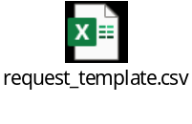
Do not delete or amend row 1 as it contains the field headings and serves as a guide to where to enter your search criteria. If the template has been opened in Excel, it must be saved as a CSV (comma separated value) file by clicking on File, Save As, and then selecting CSV from the drop down.
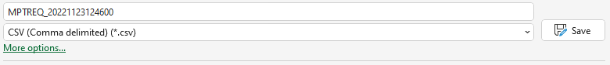
The requirement to name the request file in a specific way (i.e., MPTREQ_CCYYMMDDHHMISS.csv) has been relaxed and filenames needn’t follow this naming convention.


Sending the request file
Having successfully logged onto your MESH UI account, click the button and you will be presented with two dropdown lists.
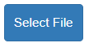
Select Master Patient Tracing System (SPINE_PDS_MESH_V1) for Select Message Type.
Select INTERNAL-SPINE - INTERNAL-SPINE for the To dropdown.
Click the button, go to the location when you saved your request file, double-click and attach.
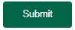
In Additional Information, you may enter a Message Subject and Reference which will be useful for matching the responses with your requests if you are sending several within a short period of time.
Click to send your request file.
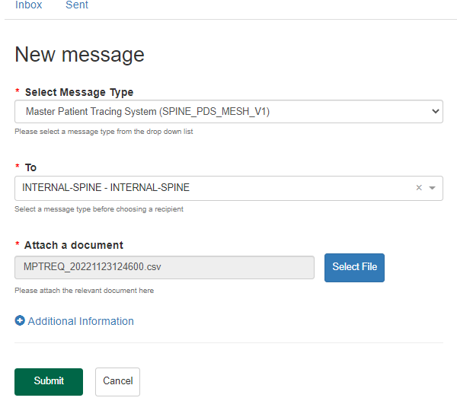

Receiving the response file
Under the Inbox tab you will be shown the messages that have been sent to your mailbox. If this information is in bold, it means that the message has not been downloaded. If a message has not been downloaded after 5 days, it will be non-delivered and removed from the list.
Clicking on the button will download that message.
Clicking on the blue link for the sender’s mailbox id (underneath the Mailbox Name heading) will bring up details about that message, along with the ability to download it by clicking the icon.
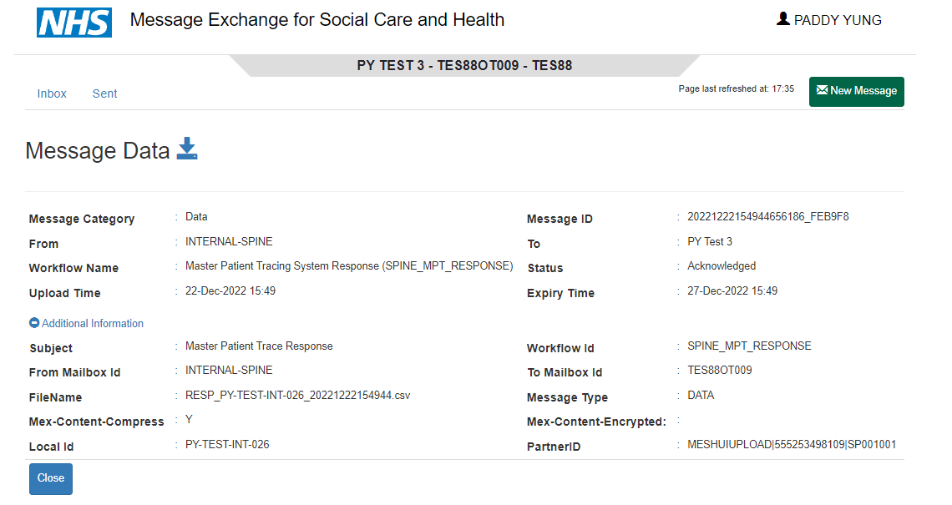

Interpreting the response file
The file that is downloaded will have a .csv extension and it will open in Excel if that is the default application for comma separated value files.
The file will contain the Unique Reference numbers from your request file and the person details if a match has been found. The ERROR/SUCCESS_CODE field will contain a 0.
If no match has been found, the cells in the row which contained the search criteria will be blank, no person details will be populated and the ERROR/SUCCESS_CODE field may contain a non-zero value if there was an error in the request. Details of ERROR/SUCCESS_CODE values can be found in the PDS MESH Data Dictionary under the Header Response Codes.

